Ggplot resources: facet_grid

<https://www.datacamp.com/community/tutorials/facets-ggplot-r?utm_source=adwords_ppc&utm_medium=cpc&utm_campaignid=14051819510&utm_adgroupid=&utm_device=c&utm_keyword=&utm_matchtype=&utm_network=x&utm_adpostion=&utm_creative=&utm_targetid=&utm_loc_interest_ms=&utm_loc_physical_ms=9009670&gclid=Cj0KCQiAieWOBhCYARIsANcOw0yHRF7JE7KgttAM4r9FDzbaL-go5T7ZH9NcAAN_gzgx3_mHZ878dboaAutrEALw_wcB>

<http://zevross.com/blog/2019/04/02/easy-multi-panel-plots-in-r-using-facet_wrap-and-facet_grid-from-ggplot2/>

<http://r-statistics.co/Top50-Ggplot2-Visualizations-MasterList-R-Code.html>

Regression resources:

<https://www.statmethods.net/stats/regression.html>

<https://cran.r-project.org/web/packages/olsrr/vignettes/variable_selection.html>

<https://365datascience.com/tutorials/statistics-tutorials/r-squared/>

**12/15/21 Meeting Notes**

Cat1: RSDI

Cat2: Modified differential emotions scales (Emotions)

Cat3: the buss-Perry aggression questionnaire (Aggression)

1. Breakdown the RSDI survey (cat 1) into 3 subcat: physical, functional, emotional
2. Make the same plot again – remove R and L endo
3. Same plot for the subset of people with CT scores
4. See if Cat 2 and Cat 3 helps explain objective scores (CT and endo scores) better than RSDI score

* Learn about the surveys on Wikipedia
* Part 1: correlation between Cat2/Cat3 and RSDI subcategories
* Part 2: regression model to see which variables explain better

1. Surgery: include those before survey & people outside of the 3-month period

* Make a separate plot
* Get the list of people with surgery but no date 🡪 give to Garret

1. Garret’s dataset

# To-Do:

1. Regression diagnostic
2. Different regression model decision: linear, lasso, ridge, elastic-net

# Scatterplots of all variables

# Removing outliers

Remove all num_allergies outliers (1.5*IQR below and above 25th and 75th percentile, respectively)

Remove only those with num_allergies >25

# Scatterplots of obs w/ CT scores

# Fitting Models

## Checking for assumptions

1. Linearity

* **Residual vs Fitted plot:** don’t want any pattern around the red line

1. Independence: predictors are independent

* **Durbin-Watson statistic**: a test for autocorrelation in a regression model's output
* Null hypothesis states that the errors are not auto-correlated with themselves (they are independent)
* p-value > 0.05: evidence to state that our independence assumption is met

1. Residual errors have mean 0

* **Residual vs Fitted plot**: want red line flat on 0

1. Residual errors have constant variance

* **Scale-Location plot**: fitted values vs the square root of the standardized residuals
* Want to see the residual points equally spread around the red line

1. Residual errors are independent from each other

* Understanding of the study design

## Model 1: endo_score ~ all others

[this is what we want to see]:

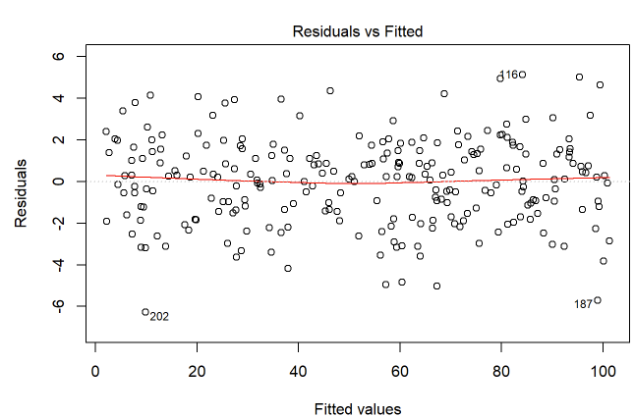

Sqrt transformed y value to fix the non-constant variance problem

[this is what we want to see]:

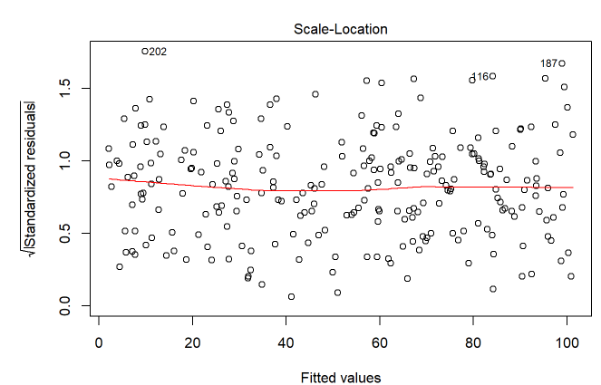

## Model 2: rsdi_emo_score ~ all others



Sqrt(y) transformation

# Histograms: before transformation

## processed_data_pruned

# Histogram: Transformed data

* Log_endo_score
* Log_rsdi_emo_score
* Log_rsdi_func_score
* Log_rsdi_phy_score
* (use the original mdes_score and aggression_score)

